Title of your abstract (Times New Roman 9pt, bold)

Author 1 ª, Author 2 ^{b}, Author 3 ^{c}, Author 4 ª, Author 5 ^{c}, … (Times New Roman 8pt )
(underlined author = presenting author)
ª Institute 1, City, Postal code, Country (Times New Roman 8pt)
^{b} Institute 2, City, Postal code, Country
^{c} Institute 3, City, Postal code, Country
e-mail: xxx@xxx.xx.xx
(e-mail of corresponding author; not necessarily the first author or the presenting author)

Keywords: (microfluidics ,coculture , cancer microenvironment, immune system)
Tumour development not only involves genetic and epigenetic changes taking place within the cell, but also multi-step processes determined collectively by diverse micro-environmental cues encountered, including cell-cell communications and physical interactions with the extracellular matrix[1,2]. Cancer cells in primary solid tumors are surrounded by a variety of other non-cancer cells, including stromal fibroblasts, endothelial cells and various immune cell populations. In addition, tumor microenvironment is also enriched of secreted soluble factors such as cytokines or growth factors thought to play a key role in the orchestration of immune cell interactions as well as in the tumorigenesis and metastatic progression. Cocultures studies in microfluidic devices could be useful for dynamic investigation of multiple cellular processes in a format more flexible than macroscale in vitro or in vivo models expanding experimental capabilities[3]. This could contribute to give an insight into the complexity of chemokines and cytokines signalling in tumors, especially focusing on the tuning of the immune system within the tumour microenvironment. Since static in vitro assays of cancer cells may lead to results not relevant in vivo, this study presents a microfluidic approach compatible with advanced live cell microscopy to study cell signalling related phenomena in tumoral and immune interacting populations mimicking more in vivo like system communication conditions. Interferon consensus sequence-binding protein (ICSBP)/interferon regulatory factor 8 (IRF-8) is a transcription factor essential for the induction of competent immune responses and acts as a tumor suppressor gene in different types of malignancies. To this end, fluorescently labeled mouse melanoma cell line (B16) and splenocytes from wild-type (WT) and Irf-8-deficient mice (KO) were successfully cocultured for one week in our microsystem to model the crosstalk of tumor microenvironment and immune system which triggers differentiated chemotactic signal recruiting splenocytes WT and KO to the tumor site. We designed the platform to support the culture of heterotypic populations in close proximity to each other, making it suitable to monitor in real time multicellular events under co-culture conditions and therefore, to model in vitro the molecular and cellular mechanisms of cancer and immune cells crosstalk modulated by a constant and simultaneous release of soluble factors in the microenvironment. From our observations of intracellular processes it may raise two important issues, one regarding the alterations in responses of immune cells recognition to tumors in mice with genetic deficiencies, the other concerning the mechanism by which tumor migration expands or is restrained in the presence of different immune systems. We found that melanoma growth was more restrained when cultured with splenocytes WT. Instead in the presence of KO splenocytes B16 cells are more attracted towards microchannels acquiring a more invasive behavior with increased cell motility. These results directly confirms how a microfluidic approach open new perspectives to reveal emergent cellular complex behaviours and closely examine highly organized cell-to-cell interactions, which may not be observed when these cells were cultured separately. As reductionist in vitro approaches have been instrumental in the elucidation of the single cellular processes, we highlight the need for the standardization of coculture protocols on chip to provide significant advance in parallel to standard macroscale cultures systems. In the perspective to elucidate the spatial and temporal dynamics and further characterize the signaling pathways, the LOC platforms integrating with real-time imaging have the potential in the coming decade to give insight about how collections of immune cells produce emergent activities (i.e, tolerance or autoimmunity) and to illuminate cancer cells responses interacting directly with their hosts via short range chemical and physical cell-to-cell contacts[4] .
[1]J. Joyce and J.W. Pollard, Nature Rev. 9 (2009) 239 -252.
[2]D.Wirtz et al., Nature 11(2011) 512-521
[3] D. Wlodkowic and J.M Cooper, Opinion Chem Biol.14 (2009)556-67.
[4] M.F. Krummel MF, Nat Immunol. 11(2010) 554-7.
.
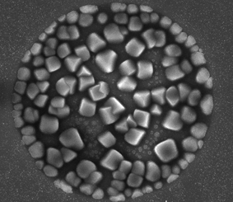 | 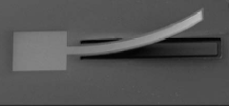
Figure 1. Insert concise explanation of figure 1 here. | Figure 2. Photographs and pictures must be of impeccable grey-scale quality.
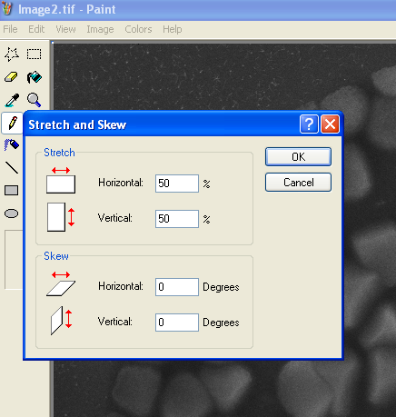 | 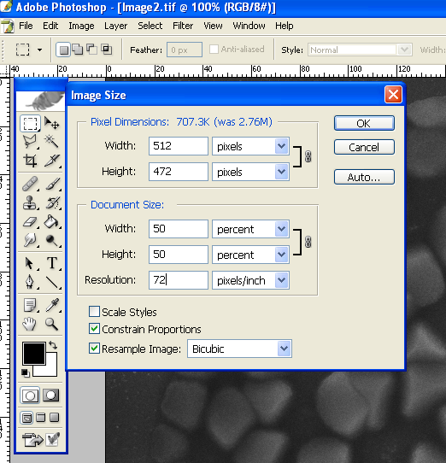
Figure 3. Stretch to 50% in MS Paint reduces the size of your image by a factor 4 (e.g. 1MB becomes 250KB upon saving your image). Use this reduced image to import in Word. | Figure 4. Resize to 50% of original in Adobe PhotoShop reduces the size of your image by a factor 4 (e.g. 1MB becomes 250KB upon saving your image). Use this reduced image to import in Word.

